**The Deployment Scheme**

In our walkthrough, we are going to install two ESXi servers, deploy vCenter Server Appliance on the first ESXi host and use the second ESXi host to run other VMs. You can add more ESXi hosts and create more VMs in your environment. Main components used in this vSphere installation and setup guide are:

ESXi 1: *192.168.11.30*

ESXi 2: *192.168.11.27*

vCenter: *192.168.11.31*

Gateway/DNS: *192.168.11.2*

Network: *192.168.11.0/255.255.255.0*

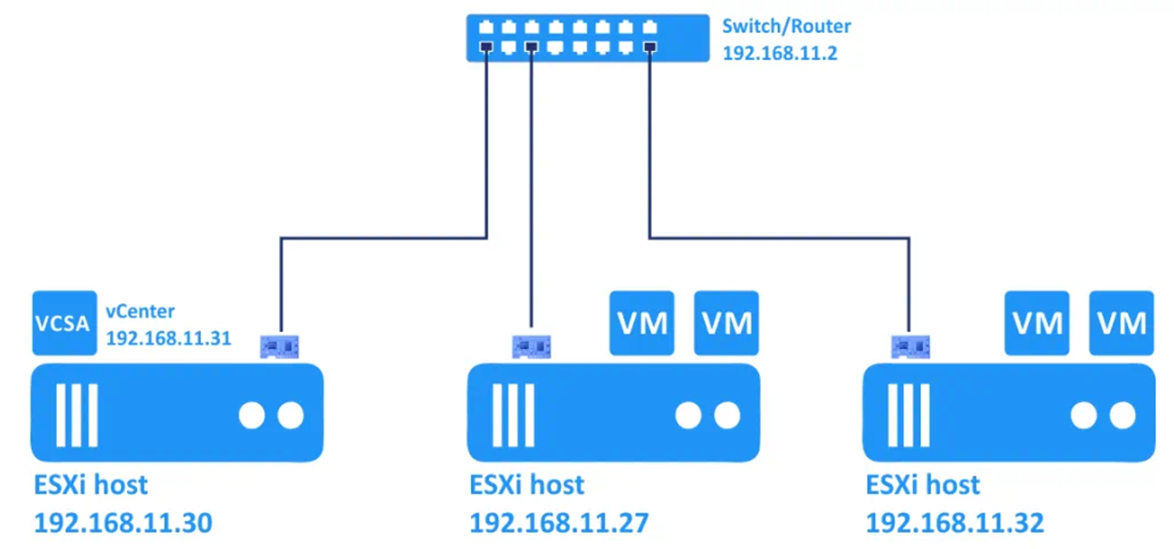

**3. Deploying ESXi Hosts - Installing ESXi on Servers**

First of all, you should deploy ESXi hosts. ESXi is a hypervisor that can run virtual machines on real hardware by using hardware emulation (virtual devices are emulated for a virtual machine). ESXi is the first type hypervisor. Prepare your physical computers/servers to install ESXi on them.

**3.1. Installing the first ESXi host**

Let’s install the first ESXi host (*192.168.11.30*) where the vCenter virtual machine will be deployed. Write the ISO image (*VMware-VMvisor-Installer-7.0.0-15843807.x86_64.iso*) to a DVD disc or USB flash drive and boot from this prepared medium to run the ESXi 7 installer on your server.

**Welcome to the VMware ESXi 7.0.0 Installation.** Read the welcome message and hit **Enter** to continue.

**End User License Agreement (EULA).** Read the EULA and press **Enter** to accept and continue.

**Select a Disk to Install or Upgrade.** In this example we have one disk to install ESXi 7.0. Later you can attach more disks, initialize them and use as datastores to store VM files. Select a storage device and hit **Enter**.

**Please select a keyboard layout.** *US Default* is used in our case. We recommend that you use the same option.

[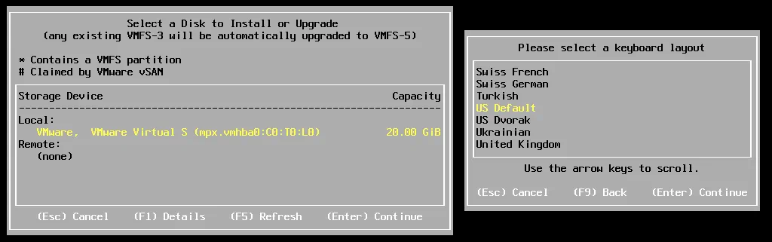](https://www.nakivo.com/blog/wp-content/uploads/2020/07/VMware-vSphere-installation-and-setup-begins-from-ESXi-installation.png)

**Enter a root password.** A password must meet the complexity requirements.

**Confirm Install.** Press **F11** to start the installation process of ESXi 7.0 on your server.

[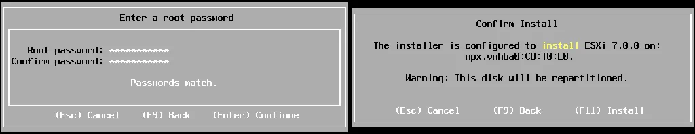](https://www.nakivo.com/blog/wp-content/uploads/2020/07/Entering-the-root-password-for-ESXi-and-installation-confirmation.png)

Wait until the installation process finishes.

**Installation Complete.** When you see this screen, it means that ESXi 7.0 has been installed successfully. Remove the installation medium and press **Enter** to reboot the machine.

[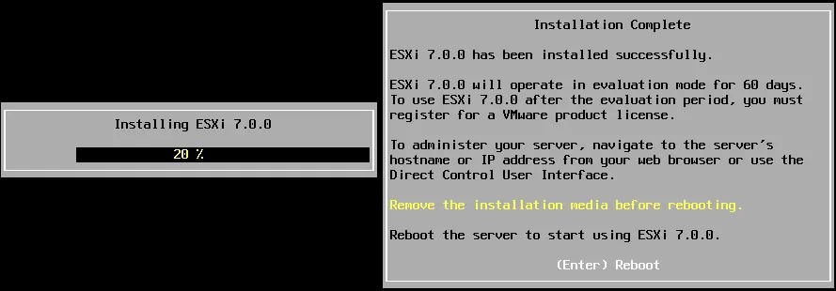](https://www.nakivo.com/blog/wp-content/uploads/2020/07/VMware-vSphere-installation-and-setup_installing-ESXi-7.png)

**3.2. Basic configuration of the ESXi host**

Once you have installed ESXi 7.0 on your server you see a grey and yellow screen that is called *ESXi direct console* (DCUI). On this screen you can see the ESXi version, build number, CPU, memory configuration, the IP address, and a link that can be opened in a web browser to manage the ESXi host.

Press **F2** to customize system.

[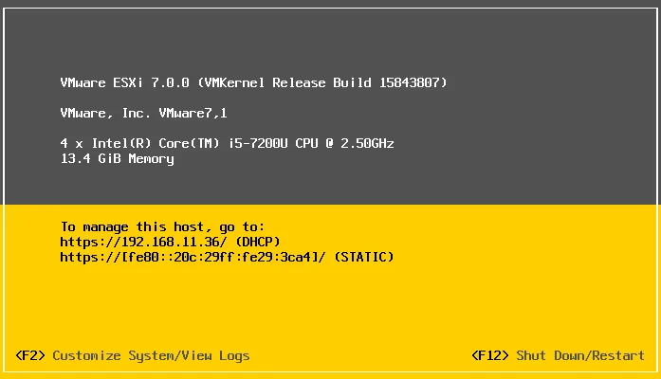](https://www.nakivo.com/blog/wp-content/uploads/2020/07/ESXi-7-is-installed-during-VMware-vSphere-setup.png)

Authentication required. Enter the root password that you have set during ESXi installation. Hit **Enter**to continue.

[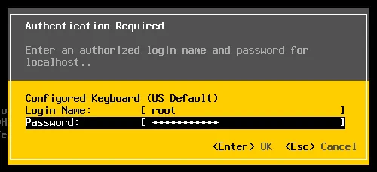](https://www.nakivo.com/blog/wp-content/uploads/2020/07/Log-into-ESXi-7-to-edit-settings-and-resume-vSphere-setup.png)

Now you are in the *System Customization* menu. In the right side of the interface you can see the current IP address assigned via DHCP. Let’s edit network settings and configure a static IP address on this ESXi host. Select **Configure Management Network** and hit **Enter**.

[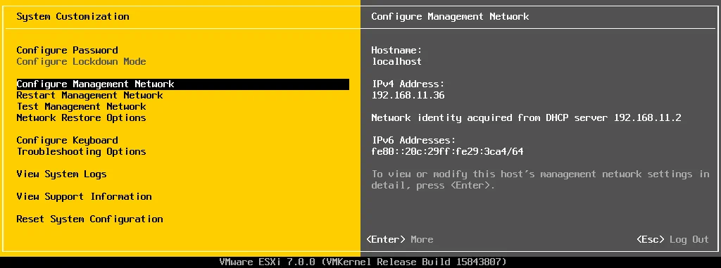](https://www.nakivo.com/blog/wp-content/uploads/2020/07/Configuring-management-network-settings-for-ESXi-is-a-part-of-vSphere-setup.png)

Select **IPv4 Configuration** and press **Enter**.

[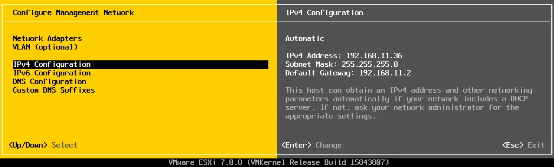](https://www.nakivo.com/blog/wp-content/uploads/2020/07/IPv4-configuration-of-ESXi-7.png)

Select **Set static IPv4 address and network configuration** and hit a **Spacebar**. We enter the following IPv4 settings:

IPv4 Address: *192.168.11.30*

Subnet Mask: *255.255.255.0*

Default Gateway: *192.168.11.2*

Hit **Enter** to save settings.

You can disable IPv6 if you don’t use this network protocol.

[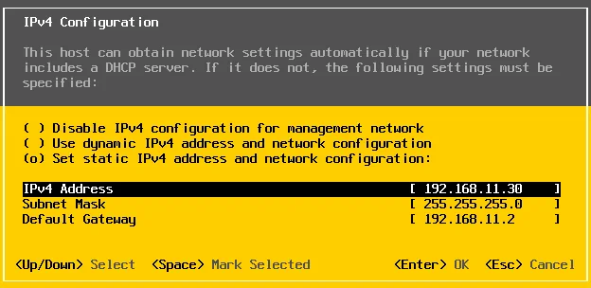](https://www.nakivo.com/blog/wp-content/uploads/2020/07/Configuring-a-static-IP-address-on-ESXi-7.png)

After that go to the **DNS Configuration**. Select **Use the following DNS server address and hostname** and press **Space**.

We use the following DNS configuration in network settings of this ESXi host:

Primary DNS Server: *192.168.11.2*

Alternative DNS Server: *192.168.11.1*

Hostname: *ESXi-30*

Hit **Enter** to save settings.

[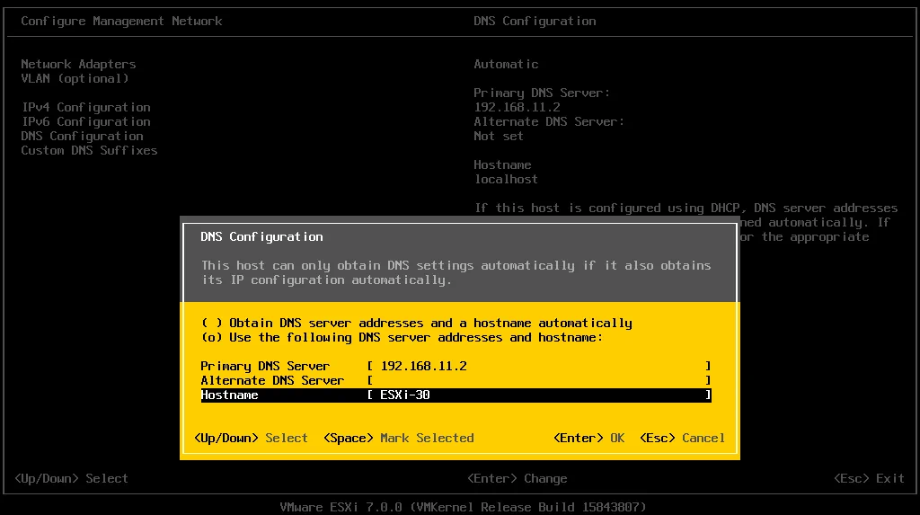](https://www.nakivo.com/blog/wp-content/uploads/2020/07/DNS-configuration-of-ESXi-7.png)

Press **Escape** to exit the *Configure Management Network* menu.

Reboot is required to apply changes. Press **Y** to reboot the ESXi host.

[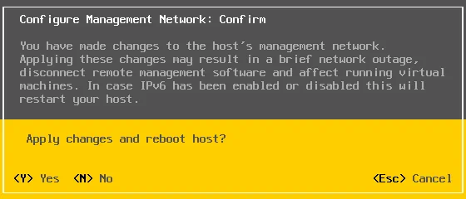](https://www.nakivo.com/blog/wp-content/uploads/2020/07/Confirmation-of-changing-ESXi-7-network-configuration.png)

After the ESXi host reboot, go to **Troubleshooting options** in the *System Customization menu*.

[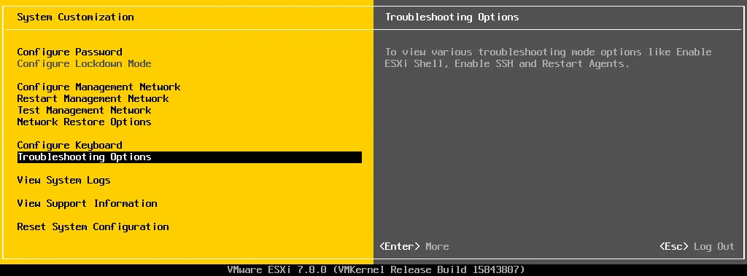](https://www.nakivo.com/blog/wp-content/uploads/2020/07/ESXi-7-Troubleshooting-options.png)

Enable **ESXi Shell** and **SSH access** for the ESXi host by selecting the appropriate option and pressing **Enter**.

[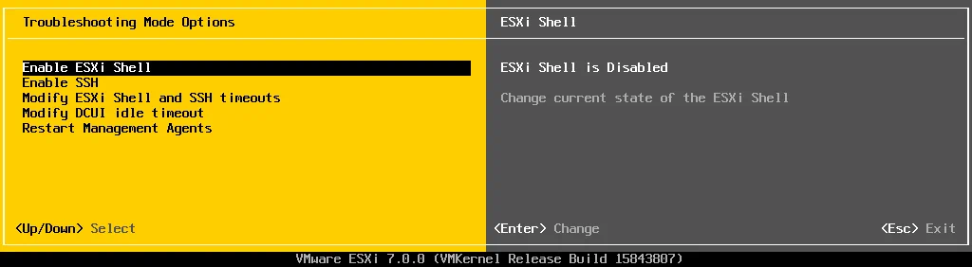](https://www.nakivo.com/blog/wp-content/uploads/2020/07/vSphere-setup_enabling-SSH-access-on-an-ESXi-7-host.png)

**3.3. Creating a datastore**

You can create a dedicated datastore to store virtual machine files.

Attach a disk or disks to your ESXi server.

***Note:*** It is recommended that you use RAID 1 or RAID 10 in production environments to provide redundancy and reduce the probability of data loss in a case of disk damage. However, using RAID cannot replace data backups. Please perform VMware VM backup in production environments to protect data.

Enter the IP address of your ESXi host in the address bar of your web browser. In our case we use *https://192.168.11.30* as the link to our ESXi host for management. Enter your user name and password to log in. In our case we use root as a username and the password set during ESXi 7 installation.

[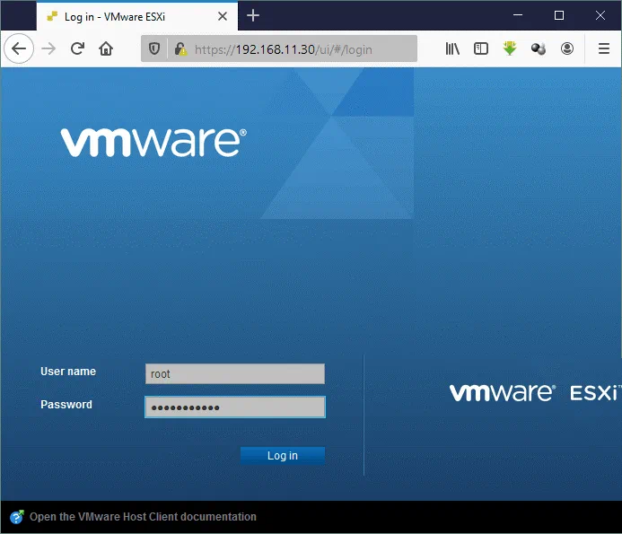](https://www.nakivo.com/blog/wp-content/uploads/2020/07/A-login-to-VMware-Host-Client.png)

Now you are using VMware Host Client to manage an ESXi host. Select **Host** in the Navigator to see the general information about an ESXi host such as version, host name, CPU, memory, and storage usage.

[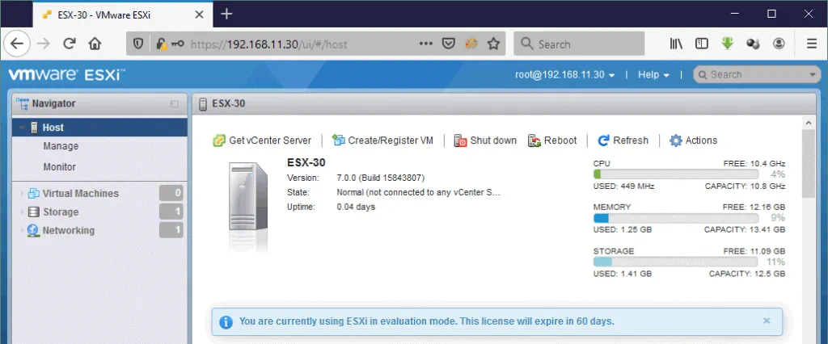](https://www.nakivo.com/blog/wp-content/uploads/2020/07/VMware-vSphere-setup_managing-an-ESXi-host-by-using-VMware-Host-Client.png)

Go to the **Storage** section in the navigation pane and in the **Datastores** tab click **New datastore**.

[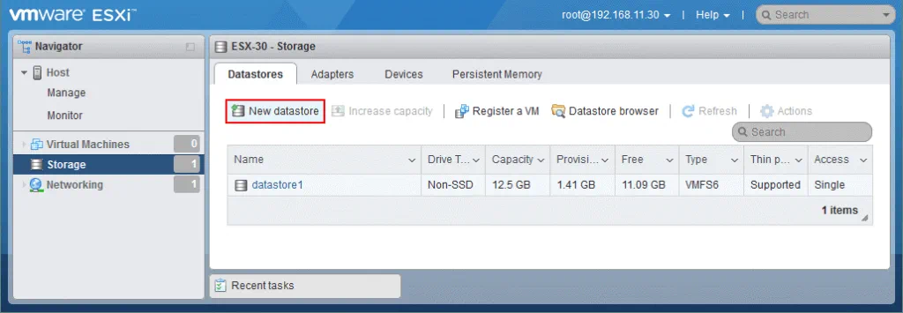](https://www.nakivo.com/blog/wp-content/uploads/2020/07/VMware-vSphere-installation-and-setup-7_creating-a-new-datastore-on-an-ESXi-7-host.png)

The datastore creation wizard opens.

**1. Select creation type.** Click **Create new VMFS datastore**.

[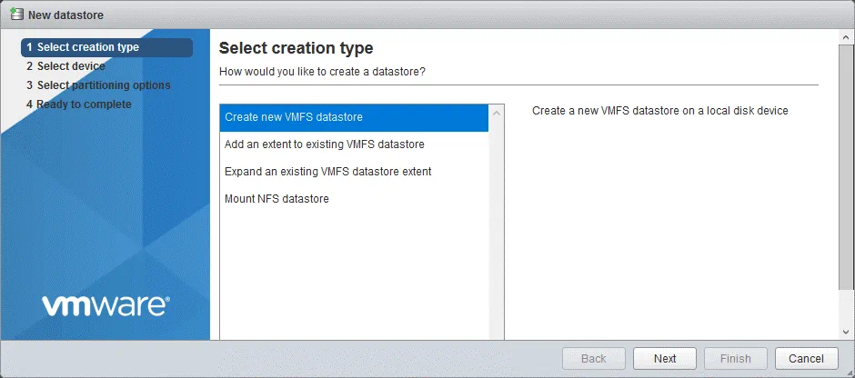](https://www.nakivo.com/blog/wp-content/uploads/2020/07/VMware-vSphere-installation-and-setup-7_creating-a-new-VMFS-datastore.png)

**2. Select device.** Select a storage device you have connected before. In our case it is a 100-GB disk. Enter the datastore name, for example, *datastore100*.

[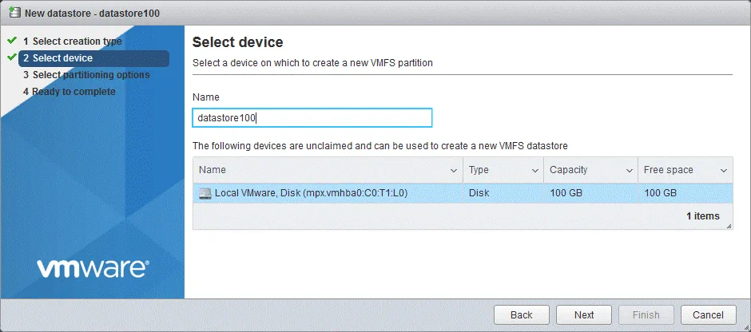](https://www.nakivo.com/blog/wp-content/uploads/2020/07/Selecting-a-device-on-which-to-create-a-new-VMFS-partition.png)

**3. Select partitioning options.** Let’s leave default options and use a full disk.

[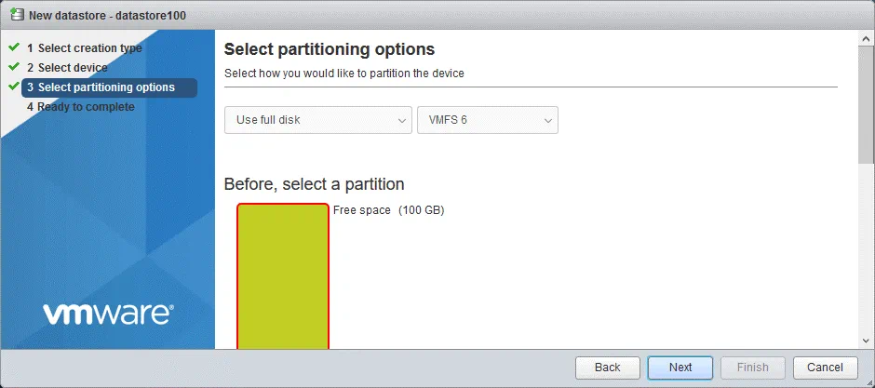](https://www.nakivo.com/blog/wp-content/uploads/2020/07/Selecting-partitioning-options.png)

**4. Ready to complete.** Hit **Finish** to create a new datastore.

[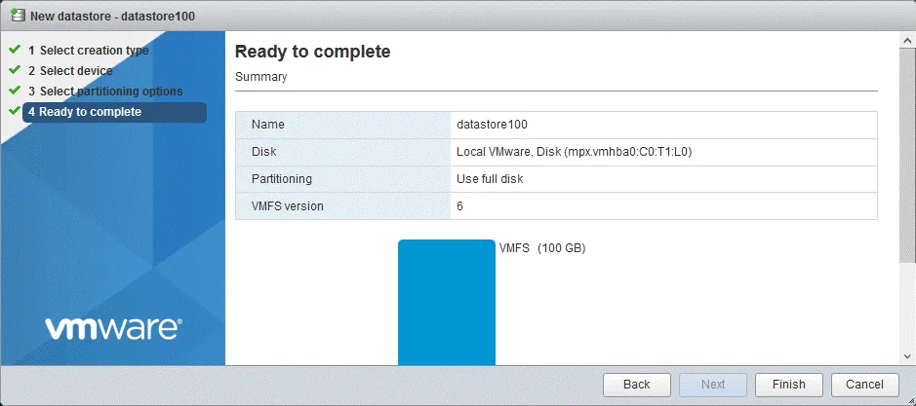](https://www.nakivo.com/blog/wp-content/uploads/2020/07/Ready-to-complete-the-partition-creation-on-ESXi-7.png)

A confirmation message is displayed:

*The entire contents of this disk are about to be erased and replaced with the specified configuration, are you sure?*

Click **Yes**.

The datastore is now created and is displayed in the list of datastores in the *Datastores* tab.

[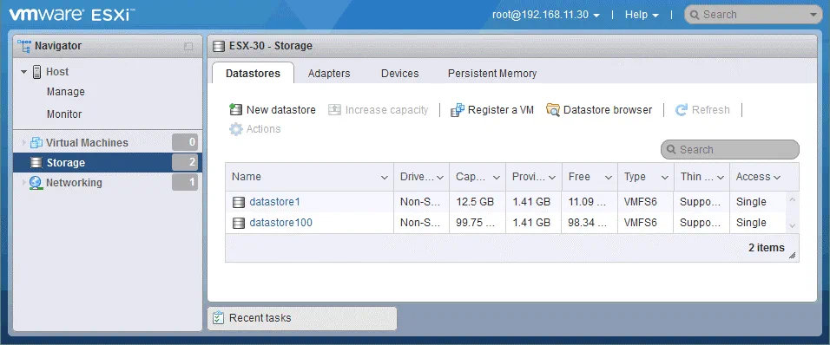](https://www.nakivo.com/blog/wp-content/uploads/2020/07/vSphere-setup_viewing-datastores-on-ESXi-7-by-using-VMware-Host-Client.png)

The first ESXi host (*192.168.11.30*) is ready to use for creating virtual machines.

**3.4. Deploying other ESXi hosts**

Similarly, we should deploy the second ESXi host (*192.168.11.27*). The second ESXi host will be used to run virtual machines in our vSphere 7 environment. You can deploy more ESXi hosts by using the workflow explained above.